BLOUBERGLOCAL MUNICIPALITY



BID DOCUMENT


TENDER NO. BM 05/19/20

POST CONNECTIONS OF DIEPSLOOT (50), SILVERMINE (45), NAILANA (22) AND INNES (71)

OCTOBER 2019

PREPARED BY: |  | PREPARED FOR:
LM MOKGOHLOA  LEFOKANE CONSULTING AND PROJECT MANAGEMENT  P.O. Box 10  SESHEGO  0742  Cell: 083 399 5522    Fax: 086 756 0323 |  | THE MUNICIPAL MANAGER  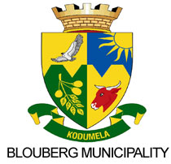  BLOUBERGLOCAL MUNICIPALITY  Private Bag x 1593  SENWABARWANA  0970  Tel: (015) 505 7100  Fax: (015) 505 0296
NAME OF BIDDER (BIDDING ENTITY) (FULL NAME, i.e. (CC, (PTY) LTD, LTD, JV, SOLE PROPRIETOR etc.) | :
TEL NUMBER | :
FAX NUMBER | :

THE OFFERED TOTAL OF THE PRICES INCLUDING VALUE ADDED TAX IS:


R………………..……….........................................................…………..(In figures)

