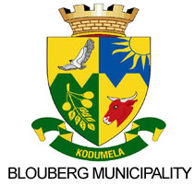

|  |
| --- |
| PUBLIC NOTICE |

***07 October 2020***

**MAYOR TO LAUNCH ELECTRIFICATION , SPORT COMPLEX AND ROAD PROJECTS**

The Mayor of Blouberg Local Municipality, His Worship Cllr Maseka Pheedi will this week conducts sod-turning ceremonies to mark the official commencement of the following projects;

**08 OCTOBER 2020**

1. Diepsloot Electrification

Time:10h00

1. Innes Electrification

Time: 12h00

1. Witten Electrification

Time : 13h30

1. Diepsloot Electrification

**DATE TO BE ANNOUNCED**

* 1. Senwabarwana bypass road
  2. Senwabarwana Sport Complex