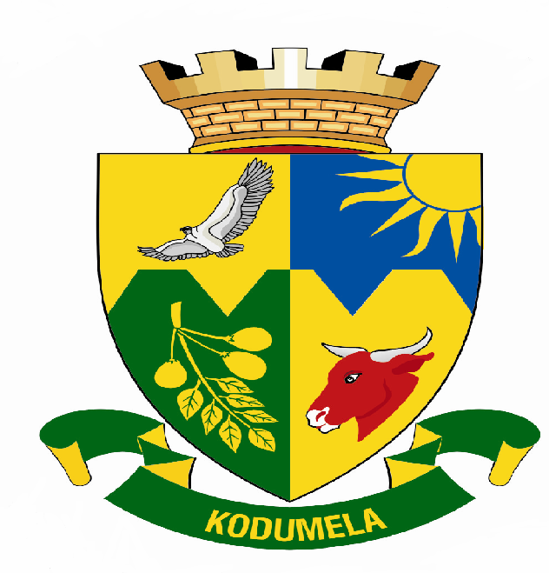
Blouberg Municipality

P.0 Box 1593
SENWABARWANA
0790
Tel: No.: 015 505 7100
Fax: No.: 015 505 0568 / 0296
E-mail: info@blouberg.limpopo.gov.za

MEDIA RELEASE
ELECTRICITY FOR THE PEOPLE

A festive light of joy for three villages in the Blouberg Municipality. The municipality has in, the pursuance of its programme dubbed Operation Liswiswi O Kotsing , registered yet another success by completing electrification projects for three villages of Motadi (85), Gedion (168) and Mokhurumela (113).

To celebrate this achievement the Mayor of Blouberg Municipality will on Thursday, 07 December 2006 switch-on these projects, starting with Mokhurumela at 10H00. The event marks an exciting beginning of the festive season for both the community as they say goodbye to darkness and the municipality as it celebrates yet another milestone in the provision of basic services to the communities.

The celebrations follow the switch-on of 63 households of Kgatlu village on the 17 November 2006 which was hugely appreciated and celebrated. Other villages whose projects have been completed and are to be switched on soon include Thorpe, Mosehleng, Cracouw, Addney, Sweethome and the Grange. Six more electrification projects for Swartz, Early Dawn, Innes, Kgokonyane, Eisorinca and Makgari are at construction stage as Operation Leswiswi O Kotsing intends to have all the outstanding villages electrified by 2009.

Issued by Communications on 05 December 2006.

For enquiries contact:
Manager Communications: Ms Phuti Matlou
Tel: 015 505 7100
Fax: 015 505 0296

